Help

Table of Contents
1. RTL 3
1.1 交换机管理主页 3
1.2 系统 3
1.2.1 系统信息 3
1.2.2 IP 地址设置 4
1.2.3 用户账户设置 4
1.2.4 端口设置 5
1.3 配置 6
1.3.1 VLAN 6
1.3.2 QOS 8
1.3.3 IGMP 15
1.3.4 STP 16
1.3.5 Trunk 组设置 21
1.3.6 环路预防设置 21
1.3.7 端口镜像设置 22
1.3.8 端口隔离设置 22
1.3.9 带宽控制设置 23
1.3.10 巨型帧设置 24
1.3.11 MAC 约束行为设置 24
1.3.12 绿色以太网设置 26
1.3.13 EEE 设置 26
1.4 安全 27
1.4.1 MAC地址 27
1.4.2 风暴控制 28
1.5 监控 29
1.5.1 端口统计信息 29
1.5.2 电缆诊断 30
1.6 工具 30
1.6.1 固件升级 30
1.6.2 配置备份 31
1.6.3 恢复配置 31
1.6.4 保存配置 31
1.6.5 重启 32
1.6.6 语言设置 32

1. RTL

1.1 交换机管理主页

Caution: Some letters were intendedly removed from the document because It was created by TRIAL version of . To get rid of this, please purchase the product.

1.2 系统

1.2.1 系统信息
设备型号 | switch
MAC地址 | 00:18:92:00:00:00
IP 地址 | 192.168.1.7
子网掩码 | 255.255.255.0
网关 | 192.168.1.1
运行时间 | 10:05:21
固件版本 | V1.0
固件日期 | Oct 6 2021

系统信息页面，用于显示系统信息。
系统信息包括设备型号、MAC地址、IP地址、子网掩码、网关、运行时间、固件版本、固件日期。
Caution: Some letters were intendedly removed from the document because It was created by TRIAL version of . To get rid of this, please purchase the product.

1.2.2 IP 地址设置
IP地址设置面，用于配置IP。
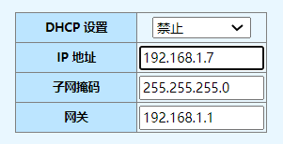
配参数如下：
1）DHCP配置：配置使能和禁止，使能时开启DHC客户端获取动态IP地址，禁止时使用配置的静态IP地址。
2）IP地址：配置静态IP地址。
3）子网掩码：配置静态IP子网掩码。
4）网关：配置网关地址
Caution: Some letters were intendedly removed from the document because It was created by TRIAL version of . To get rid of this, please purchase the product.

1.2.3 用户账户设置
窗体底端
用户账户设置页面，用于配置用户账户。
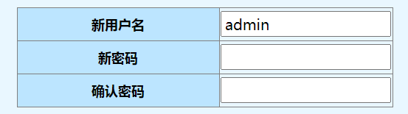
配置参数如下：
1）新用户名：添加新用户名。
2）新密码：添加新用户密码。
3）确认密码：确认新用户密码。
Caution: Some letters were intendedly removed from the document because It was created by TRIAL version of . To get rid of this, please purchase the product.

1.2.4 端口设置
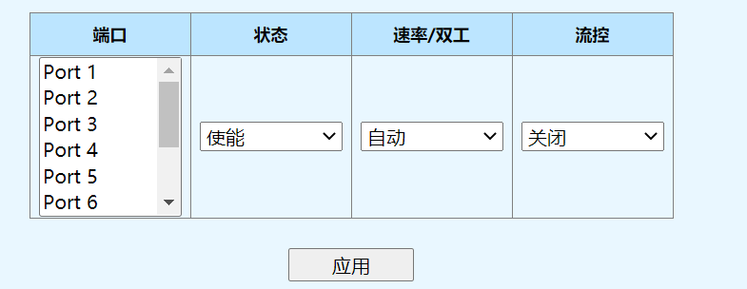
窗体底端

端口 | 状态 | 速率/双工 |  | 流控
端口 | 状态 | 配置 | 当前 | 配置 | 当前
Port 1 | 使能 | 自动 | 连接断开 | 开启 | 关闭
Port 2 | 使能 | 自动 | 1000Full | 开启 | 开启
Port 3 | 使能 | 自动 | 连接断开 | 开启 | 关闭
Port 4 | 使能 | 自动 | 连接断开 | 开启 | 关闭
Port 5 | 使能 | 自动 | 连接断开 | 开启 | 关闭
Port 6 | 使能 | 自动 | 连接断开 | 开启 | 关闭
Port 7 | 使能 | 自动 | 连接断开 | 开启 | 关闭
Port 8 | 使能 | 自动 | 连接断开 | 开启 | 关闭
Port 9 | 使能 | 自动 | 连接断开 | N/A | N/A
Port 10 | 使能 | 自动 | 连接断开 | N/A | N/A

端口配置页面用于配置端口显示端口状态
配置参数如下：
1）端口：指定配置的端口。
2）状态：配置端口使能或禁止。
3)速率/双工：配置速率/双工模式，模式包括自动、10M/Half、10M/Full、100M/Half、100M/Full、1000M/Full。
4）流控：配置流控开启或关闭。
显示信包括端口、状态使能或禁止、速率/双工配置、速率/双工状态、流控配置、流控当前状态。
Caution: Some letters were intendedly removed from the document because It was created by TRIAL version of . To get rid of this, please purchase the product.

1.3 配置

1.3.1 VLAN

1.3.1.1 静态VLAN表
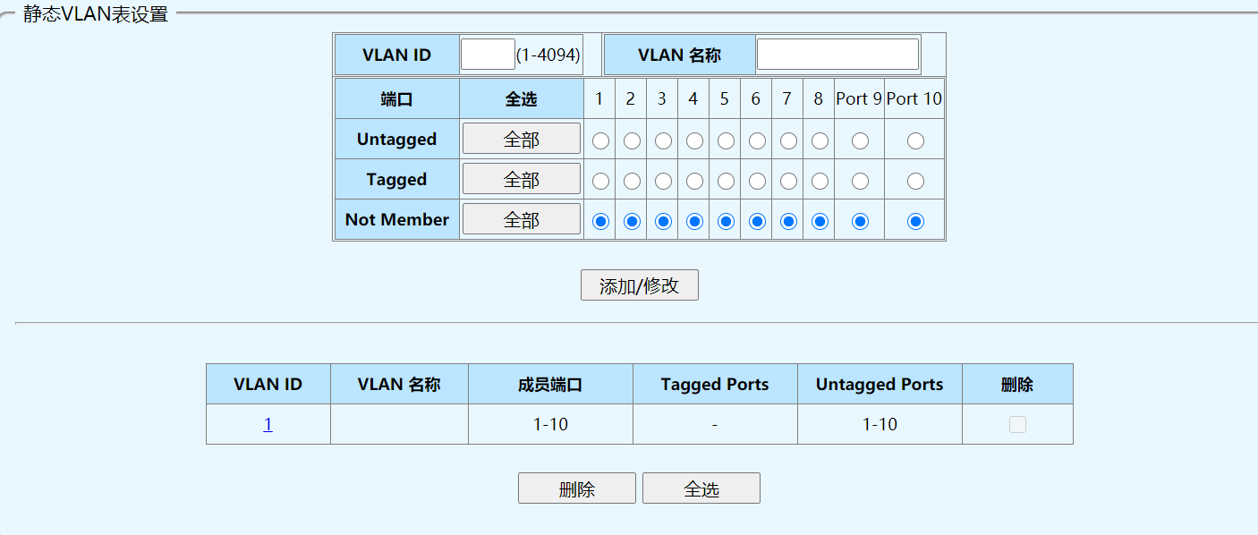
窗体底端
静态VLAN表设置页面，用于将VLAN以tag或者untag形式加入端口或端口删除，同时显示VLAN加入的端口信息。
Caution: Some letters were intendedly removed from the document because It was created by TRIAL version of . To get rid of this, please purchase the product.

1.3.1.2 VLAN 端口设置

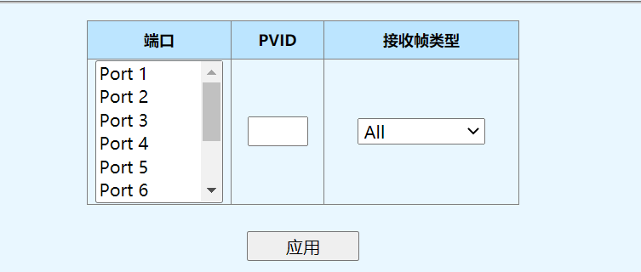

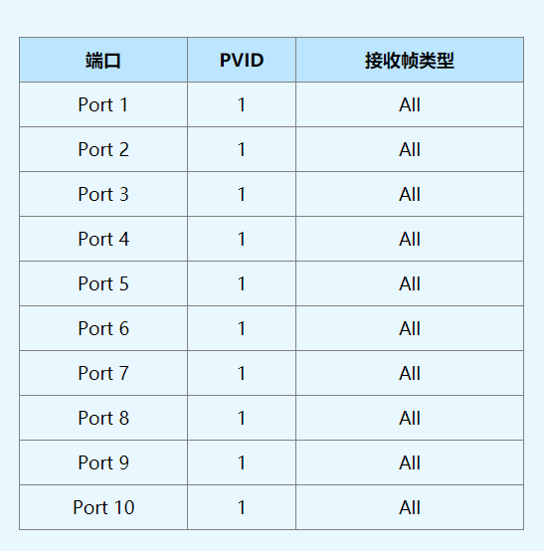
VLAN端设置页面，用于配置端口的PVID，接收帧类型。
Caution: Some letters were intendedly removed from the document because It was created by TRIAL version of . To get rid of this, please purchase the product.

1.3.2 QOS

1.3.2.1 优先级选择设置
窗体顶端
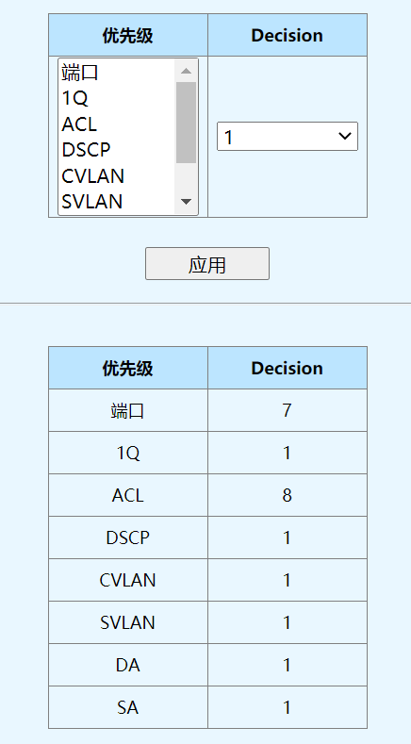
优先级选择设置页面，用于配置优先级源权重，当收到数据包与多个源配对时，将选择由权重最高的源分配优先级。
Caution: Some letters were intendedly removed from the document because It was created by TRIAL version of . To get rid of this, please purchase the product.

1.3.2.2 DSCP 重新映射设置

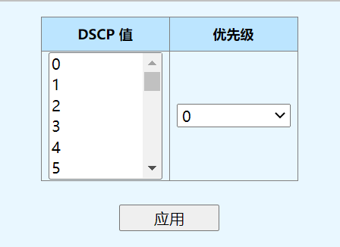
DSCP 值 | 优先级
0 | 0
1 | 0
2 | 0
3 | 0
4 | 0
5 | 0
6 | 0
7 | 0
8 | 0
9 | 0
10 | 0
11 | 0
12 | 0
13 | 0
14 | 0
15 | 0
16 | 0
17 | 0
18 | 0
19 | 0
20 | 0
21 | 0
22 | 0
23 | 0
24 | 0
25 | 0
26 | 0
27 | 0
28 | 0
29 | 0
30 | 0
31 | 0
32 | 0
33 | 0
34 | 0
35 | 0
36 | 0
37 | 0
38 | 0
39 | 0
40 | 0
41 | 0
42 | 0
43 | 0
44 | 0
45 | 0
46 | 0
47 | 0
48 | 0
49 | 0
50 | 0
51 | 0
52 | 0
53 | 0
54 | 0
55 | 0
56 | 0
57 | 0
58 | 0
59 | 0
60 | 0
61 | 0
62 | 0
63 | 0

DSCP重新映射设置页面，用于配置基于DSCP优先级到内部优先级映射。
Caution: Some letters were intendedly removed from the document because It was created by TRIAL version of . To get rid of this, please purchase the product.

1.3.2.3 优先级队列ID设置

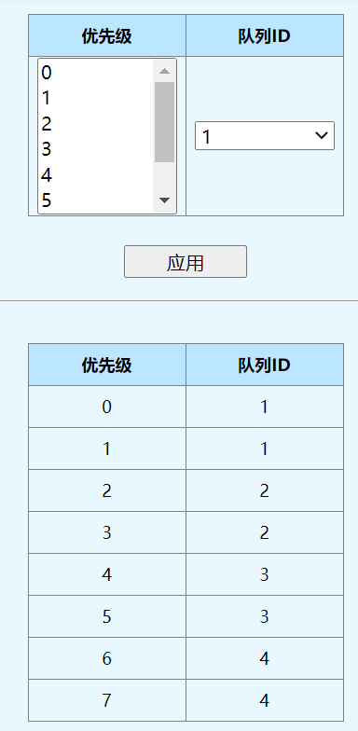
优先级队列ID设置页面，用于配置内部优先级到队列的映射。
Caution: Some letters were intendedly removed from the document because It was created by TRIAL version of . To get rid of this, please purchase the product.

1.3.2.4 端口优先级设置

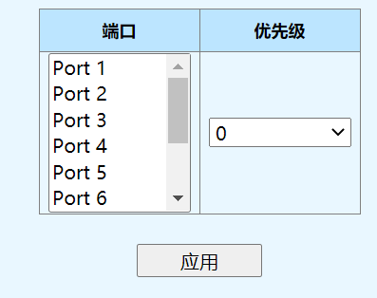

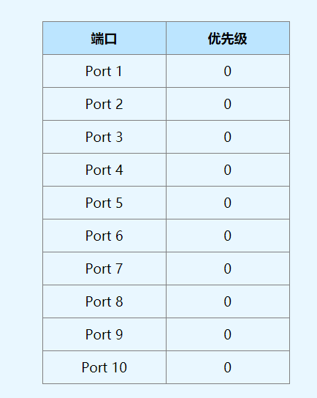
端口优先级设置页面，用于配置基于端口优先级。
Caution: Some letters were intendedly removed from the document because It was created by TRIAL version of . To get rid of this, please purchase the product.

1.3.2.5 队列权重设置

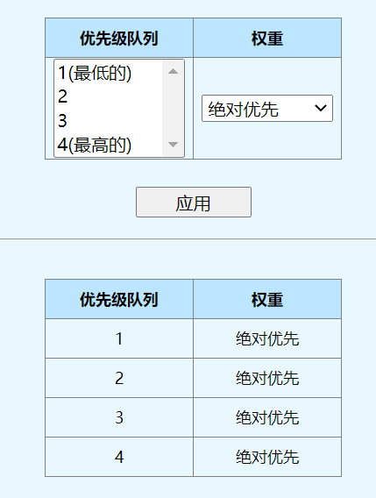
队列权重页面，用于配置队列优先级算法权重。
Caution: Some letters were intendedly removed from the document because It was created by TRIAL version of . To get rid of this, please purchase the product.

1.3.3 IGMP

1.3.3.1 IGMP

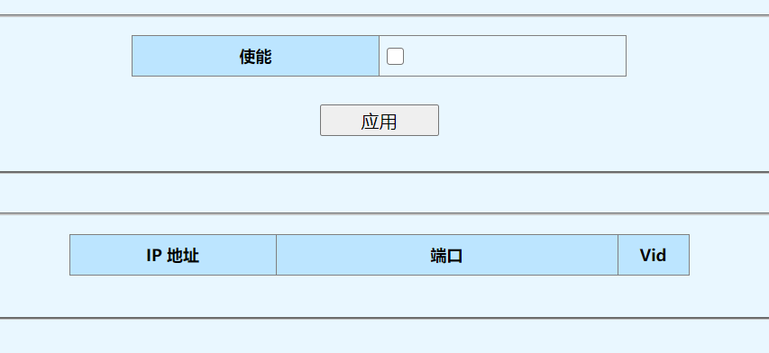
IGMP页面，用于配置IGMP使能或非使能和显示IGMP列表项
勾选使能后，通过IGMP协议学习的组播报文才允许通过。
显示信息包括通过IGMP学习到的IP地址、所属端口、所属VLAN ID。
Caution: Some letters were intendedly removed from the document because It was created by TRIAL version of . To get rid of this, please purchase the product.

1.3.4 STP

1.3.4.1 STP 端口概要
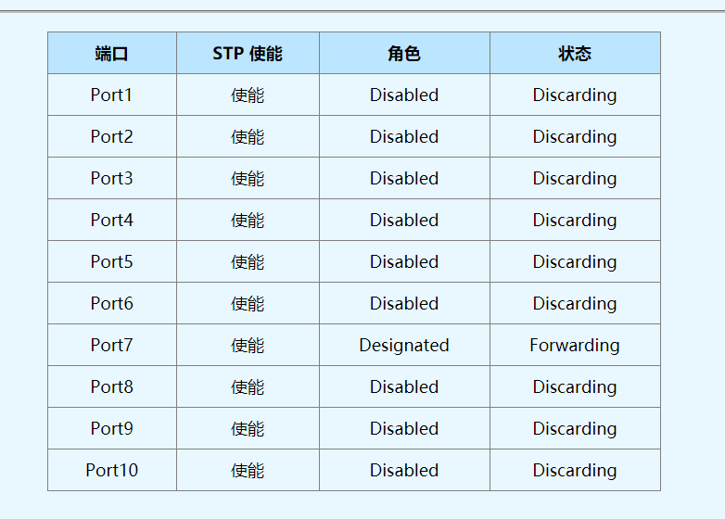
STP端口概要页面，用于显示端口STP概要信息，包括端口、STP使能、角色、状态
Caution: Some letters were intendedly removed from the document because It was created by TRIAL version of . To get rid of this, please purchase the product.

1.3.4.2 STP 全局设置
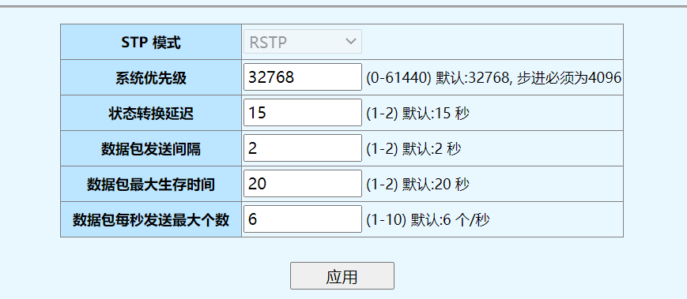
窗体底端
STP全局设置页面，用于配置STP全局参数
Caution: Some letters were intendedly removed from the document because It was created by TRIAL version of . To get rid of this, please purchase the product.

1.3.4.3 STP 端口设置
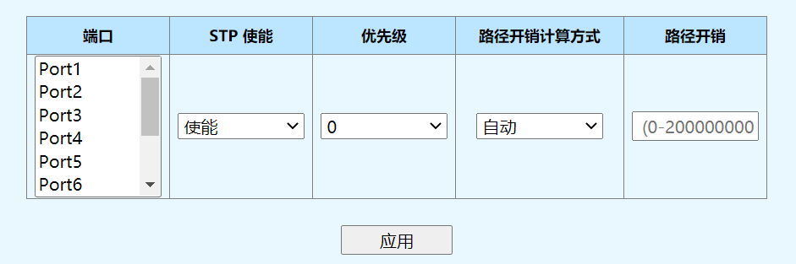
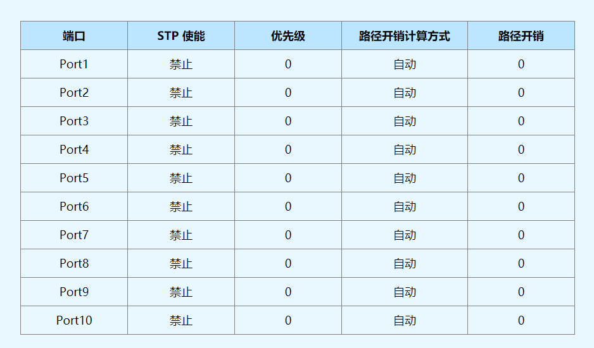

STP端口设置页面，用于配置STP端口参数
Caution: Some letters were intendedly removed from the document because It was created by TRIAL version of . To get rid of this, please purchase the product.

1.3.4.4 STP 端口信息
STP端口信息
端口 | 优先级 | STP 使能 | 点对点 | 路径开销 | 角色 | 连接状态 | 状态 | 发送 RSTP
Port1 | 0 | 禁止 | No | 0 | Disabled | 连接断开 | Discarding | False
Port2 | 0 | 禁止 | No | 0 | Disabled | 连接断开 | Discarding | False
Port3 | 0 | 禁止 | No | 0 | Disabled | 连接断开 | Discarding | False
Port4 | 0 | 禁止 | No | 0 | Disabled | 连接断开 | Discarding | False
Port5 | 0 | 禁止 | No | 0 | Disabled | 连接断开 | Discarding | False
Port6 | 0 | 禁止 | No | 0 | Disabled | 连接断开 | Discarding | False
Port7 | 0 | 禁止 | No | 0 | Disabled | 连接断开 | Discarding | False
Port8 | 0 | 禁止 | No | 0 | Disabled | 连接断开 | Discarding | False
Port9 | 0 | 禁止 | No | 0 | Disabled | 连接断开 | Discarding | False
Port10 | 0 | 禁止 | No | 0 | Disabled | 连接断开 | Discarding | False

端口优先级向量
端口 | 根桥 | 根路径开销 | 指定网桥 | 指定端口 | 接收端口
Por1 | 000000000000 /0 | 0 | 000000000000 /0 | N/A /0 | N/A /0
Port2 | 000000000000 /0 | 0 | 000000000000 /0 | N/A /0 | NA /0
Port3 | 000000000000 /0 | 0 | 000000000000 /0 | N/A /0 | N/A /0
Port4 | 000000000000 /0 | 0 | 000000000000 /0 | N/A /0 | N/A /0
Port5 | 000000000000 /0 | 0 | 000000000000 /0 | N/A /0 | N/A /0
Port6 | 000000000000 /0 | 0 | 000000000000 /0 | N/A /0 | N/A /0
Port7 | 000000000000 /0 | 0 | 000000000000 /0 | N/A /0 | N/A /0
Port8 | 000000000000 /0 | 0 | 000000000000 /0 | N/A /0 | N/A /0
Port9 | 000000000000 /0 | 0 | 000000000000 /0 | N/A /0 | N/A /0
Port10 | 000000000000 /0 | 0 | 000000000000 /0 | N/A /0 | N/A /0

端口时间信息
端口 | 状态转换延迟 | 数据包发送间隔 | 数据包最大生存时间 | 消息生存时间
Port1 | 0 | 0 | 0 | 0
Port2 | 0 | 0 | 0 | 0
Port3 | 0 | 0 | 0 | 0
Port4 | 0 | 0 | 0 | 0
Port5 | 0 | 0 | 0 | 0
Port6 | 0 | 0 | 0 | 0
Port7 | 0 | 0 | 0 | 0
Port8 | 0 | 0 | 0 | 0
Port9 | 0 | 0 | 0 | 0
Port10 | 0 | 0 | 0 | 0

端口消息优先级向量
端口 | 根桥 | 根路径开销 | 指定网桥 | 指定端口 | 接收端口
Port1 | 000000000000 /0 | 0 | 000000000000 /0 | N/A /0 | N/A /0
Port2 | 000000000000 /0 | 0 | 000000000000 /0 | N/A /0 | N/A /0
Port3 | 000000000000 /0 | 0 | 000000000000 /0 | N/A /0 | N/A /0
Port4 | 000000000000 /0 | 0 | 000000000000 /0 | N/A /0 | N/A /0
Port5 | 000000000000 /0 | 0 | 000000000000 /0 | N/A /0 | N/A /0
Port6 | 000000000000 /0 | 0 | 000000000000 /0 | N/A /0 | N/A /0
Port7 | 000000000000 /0 | 0 | 000000000000 /0 | N/A /0 | N/A /0
Port8 | 000000000000 /0 | 0 | 000000000000 /0 | N/A /0 | N/A /0
Port9 | 000000000000 /0 | 0 | 000000000000 /0 | N/A /0 | N/A /0
Port10 | 000000000000 /0 | 0 | 000000000000 /0 | N/A /0 | N/A /0

STP端口信息页面，用于显示STP端口的详细信息
Caution: Some letters were intendedly removed from the document because It was created by TRIAL version of . To get rid of this, please purchase the product.

1.3.4.5 STP 详细信息
当前网桥 | 001892000000 /32768
根桥端口 | N/A
指定端口
备份/更改端口
禁用端口

根桥优先级向量
根桥 | 根径开销 | 指定网桥 | 指定口 | 接收端口
001892000000 /32768 | 0 | 001892000000 /32768 | N/A /0 | N/A /0

根桥时间信息
状态转换延迟 | 数据发送间隔 | 数据包最大生时间 | 消息生时间
15 | 2 | 20 | 0

STP详细息页面，用于显示STP详细信息
Caution: Some letters were intendedly removed from the document because It was created by TRIAL version of . To get rid of this, please purchase the product.

1.3.5 Trunk 组设置
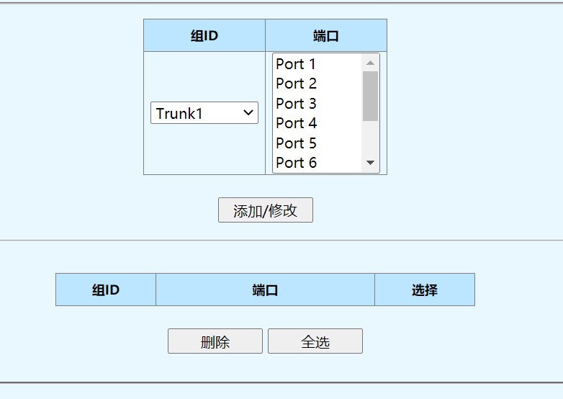
窗体底端
Trunk组设置页面，用于配置端口聚合。
Caution: Some letters were intendedly removed from the document because It was created by TRIAL version of . To get rid of this, please purchase the product.

1.3.6 环路预防设置
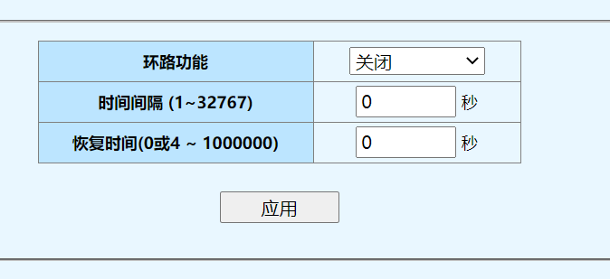
窗体底端
环路预防页面，用于配置环路保护功能
Caution: Some letters were intendedly removed from the document because It was created by TRIAL version of . To get rid of this, please purchase the product.

1.3.7 端口镜像设置
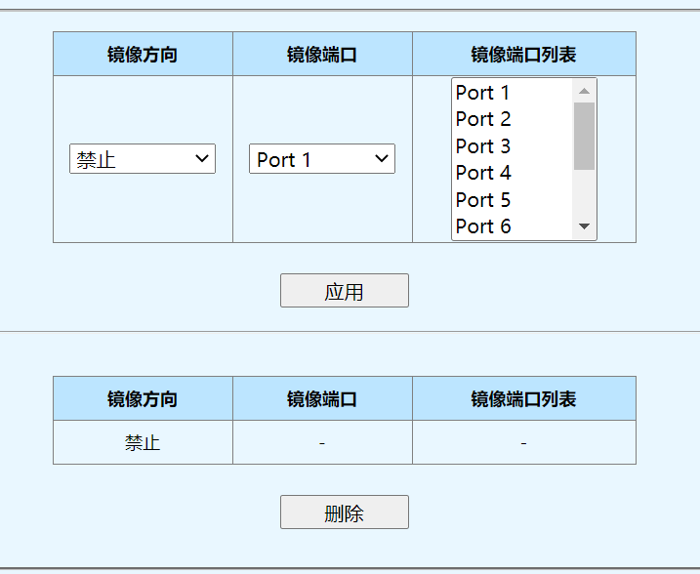
窗体底端
端口镜像设置页面，用于配置基于端口的镜像。
Caution: Some letters were intendedly removed from the document because It was created by TRIAL version of . To get rid of this, please purchase the product.

1.3.8 端口隔离设置
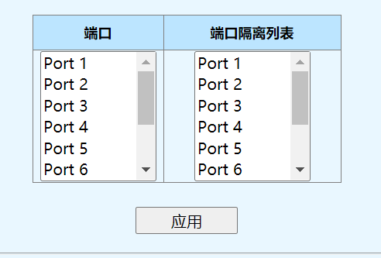
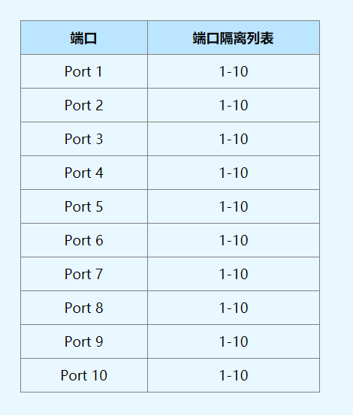
端口隔离设置页面，用于配置端口隔离。
Caution: Some letters were intendedly removed from the document because It was created by TRIAL version of . To get rid of this, please purchase the product.

1.3.9 带宽控制设置
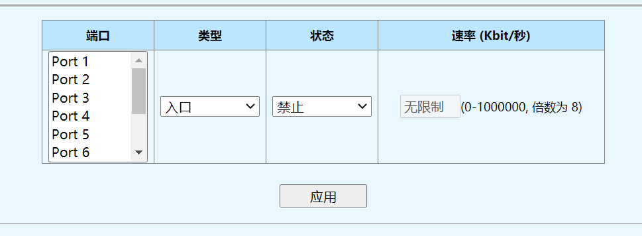
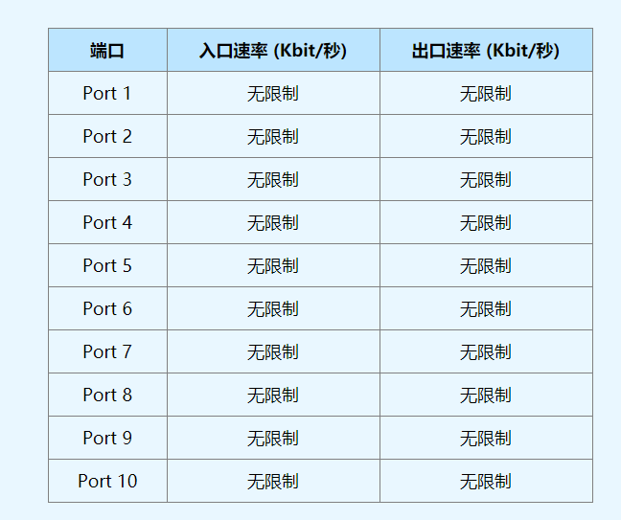
带宽控制设置页面，用于配置端口进出的报文带宽
Caution: Some letters were intendedly removed from the document because It was created by TRIAL version of . To get rid of this, please purchase the product.

1.3.10 巨型帧设置
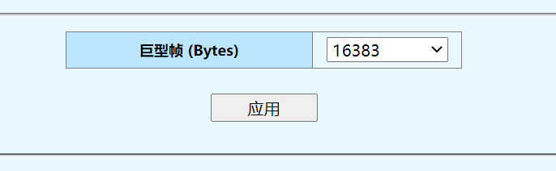

巨型帧设置页面，用于配置允许通的最大帧长，单位Bytes。支持1522、1536、1552、16383四种帧长。
Caution: Some letters were intendedly removed from the document because It was created by TRIAL version of . To get rid of this, please purchase the product.

1.3.11 MAC 约束行为设置
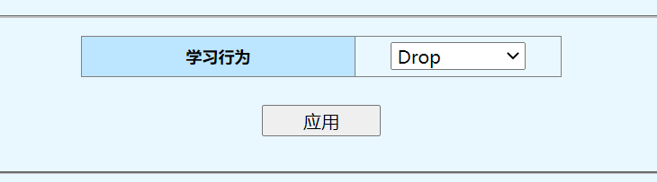
窗体底端

MAC 约束设置
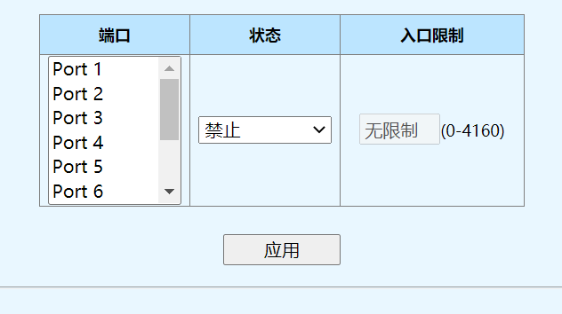
窗体底端

端口 | 入口限制
Port 1 | 无限制
Port 2 | 无限制
Port 3 | 无限制
Port 4 | 无限制
Port 5 | 无限制
Port 6 | 无限制
Port 7 | 无限制
Port 8 | 无限制
Port 9 | 无限制
Port 10 | 无限制

MAC约束行为页面，用于配置端口允许学习的MAC数量及对端口学到的MAC地址的处理行为。
Caution: Some letters were intendedly removed from the document because It was created by TRIAL version of . To get rid of this, please purchase the product.

1.3.12 绿色以太网设置
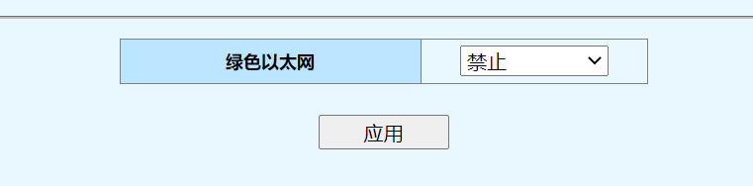
绿色以太网设置页面，用于使能或禁止绿色以太网功能。通过设置绿色以太网功能，以降低能耗。当绿色功能启用时系统将自动检测缆线长度，选择不同的功率模式，以获得最佳的性能和最小的功耗，若连接断开后，0秒内端口将入省电模式。
Caution: Some letters were intendedly removed from the document because It was created by TRIAL version of . To get rid of this, please purchase the product.

1.3.13 EEE 设置
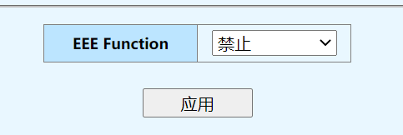
窗体底端
EEE页面，用于使能或禁止高效节能以太网，遵循标准IEEE 802.3az。
Caution: Some letters were intendedly removed from the document because It was created by TRIAL version of . To get rid of this, please purchase the product.

1.4 安全

1.4.1 MAC地址

1.4.1.1 MAC 地址搜索
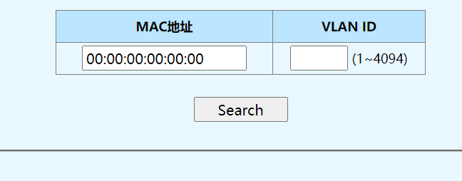
窗体底端
MAC地址搜索页面,用于查询MAC地址并显示VLAN ID。
查询参数如下
1）MAC地址
2）VLAN ID
显示信包括MAC AddressVLAN ID、类型（静态或动态）、端口
Caution: Some letters were intendedly removed from the document because It was created by TRIAL version of . To get rid of this, please purchase the product.

1.4.1.2 静态MAC设置
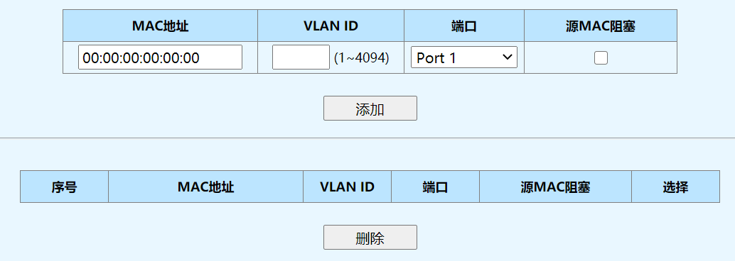
窗体底端
静态MAC页面,用于添加、显示和删除端口静态MAC地址。
配置参数如下：
1）MAC地址：添加的静态MAC地址。
2）VLAN ID：添加的静态MAC所属的VLAN。
3）端口：添加的静态MAC所属的端口。
4）源MAC阻塞：若勾此选项，携带此MAC的报文不允许通过。
Caution: Some letters were intendedly removed from the document because It was created by TRIAL version of . To get rid of this, please purchase the product.

1.4.2 风暴控制
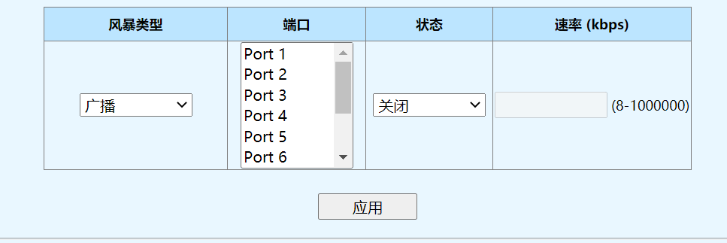
窗体底端

端口 | 广播 (kbps) | 多播 (kbps) | 未知单播 (kbps) | 未知多播 (kbps)
Port 1 | 关闭 | 关闭 | 关闭 | 关闭
Port 2 | 关闭 | 关闭 | 关闭 | 关闭
Port 3 | 关闭 | 关闭 | 关闭 | 关闭
Port 4 | 关闭 | 关闭 | 关闭 | 关闭
Port 5 | 关闭 | 关闭 | 关闭 | 关闭
Port 6 | 关闭 | 关闭 | 关闭 | 关闭
Port 7 | 关闭 | 关闭 | 关闭 | 关闭
Port 8 | 关闭 | 关闭 | 关闭 | 关闭
Port 9 | 关闭 | 关闭 | 关闭 | 关闭
Port 10 | 关闭 | 关闭 | 关闭 | 关闭

风暴抑制页面，用于泛洪报文的抑制
配置数如下
1）风暴类型：配置风暴类型包括广播、多播、未知单播、未知多播
2）状态：配置风暴抑制开启或关闭。
3）端口：配置风暴抑制生效的端口。
4）速率（kpbs）：配置抑制速率，范围8-1000000kbps。
Caution: Some letters were intendedly removed from the document because It was created by TRIAL version of . To get rid of this, please purchase the product.

1.5 监控

1.5.1 端口统计信息
窗体顶端
端口 | 状态 | 连接状态 | TxGoodPkt | TxBadPkt | RxGoodPkt | RxBadPkt
Port 1 | 使能 | 连接断开 | 0 | 0 | 0 | 0
Port 2 | 使能 | 恢复连接 | 1743 | 0 | 533 | 0
Port 3 | 使能 | 连接断开 | 0 | 0 | 0 | 0
Port 4 | 使能 | 连接断开 | 0 | 0 | 0 | 0
Port 5 | 使能 | 连接断开 | 0 | 0 | 0 | 0
Port 6 | 使能 | 连接断开 | 0 | 0 | 0 | 0
Port 7 | 使能 | 连接断开 | 0 | 0 | 0 | 0
Port 8 | 使能 | 连接断开 | 0 | 0 | 0 | 0
Port 9 | 使能 | 连接断开 | 0 | 0 | 0 | 0
Port 10 | 使能 | 连接断开 | 0 | 0 | 0 | 0
窗体底端
端口统计页面，用于显示端口统计信息
显示信包括端口的状态、连接状态、发送的正确数据包、发送的错误数据包、接收的正确数据包、接收的错误数据包。
Caution: Some letters were intendedly removed from the document because It was created by TRIAL version of . To get rid of this, please purchase the product.

1.5.2 电缆诊断
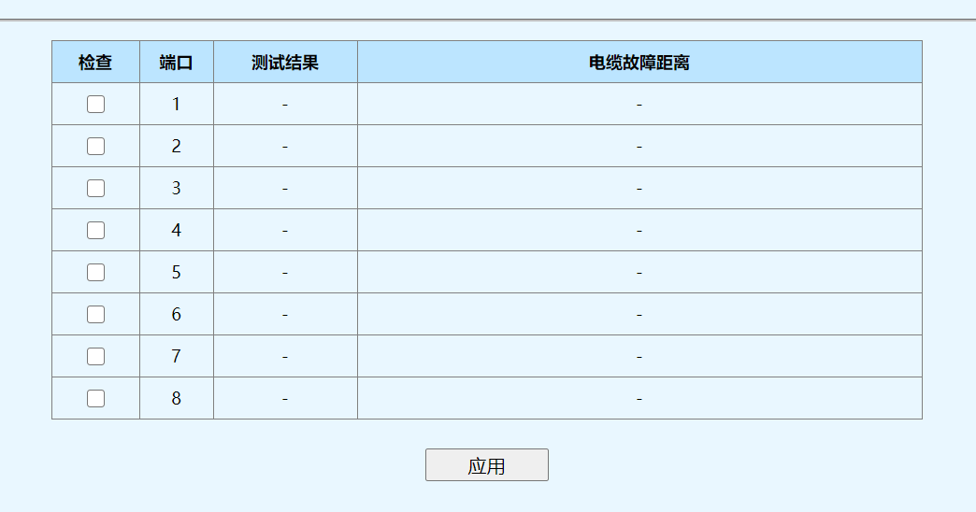
窗体底端
电缆诊断页面，用于诊断网络线路是否正常。
Caution: Some letters were intendedly removed from the document because It was created by TRIAL version of . To get rid of this, please purchase the product.

1.6 工具

1.6.1 固件升级
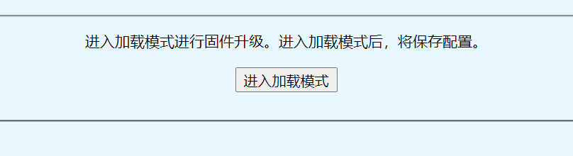
窗体底端
固件升级页面，用于进入加载模式，在加载模式中进行升级。
Caution: Some letters were intendedly removed from the document because It was created by TRIAL version of . To get rid of this, please purchase the product.

1.6.2 配置备份
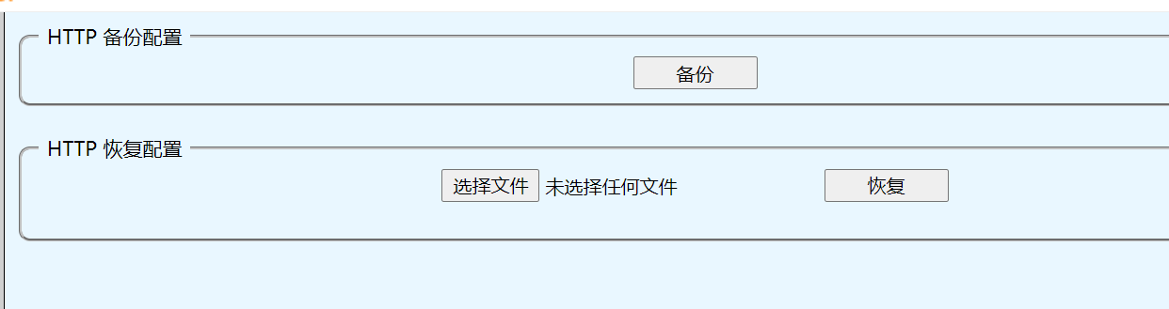
配置备份页面，用于配置导入导出，点击备份按钮，可以将配置导出到PC备份，点击恢复配置的选择文件按钮，选中PC备份的配置，再点击恢复按钮，将备份配置导入设备。
Caution: Some letters were intendedly removed from the document because It was created by TRIAL version of . To get rid of this, please purchase the product.

1.6.3 恢复配置
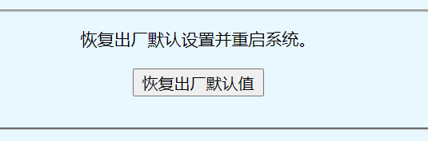
窗体底端
恢复配置页面，用于恢复出厂设置，进入重置页面，点击恢复出厂默认值按钮，系统将重启同时恢复到出厂默认配置。
Caution: Some letters were intendedly removed from the document because It was created by TRIAL version of . To get rid of this, please purchase the product.

1.6.4 保存配置

保存页面，用于保存配置，点击保存页面后，将立即进行系统配置保存，配置保存页面将显示配置已经保存成功。
Caution: Some letters were intendedly removed from the document because It was created by TRIAL version of . To get rid of this, please purchase the product.

1.6.5 重启

窗体底端
重启页面，用于重启设备。
Caution: Some letters were intendedly removed from the document because It was created by TRIAL version of . To get rid of this, please purchase the product.

